Traffic assignment methods(algorithms)

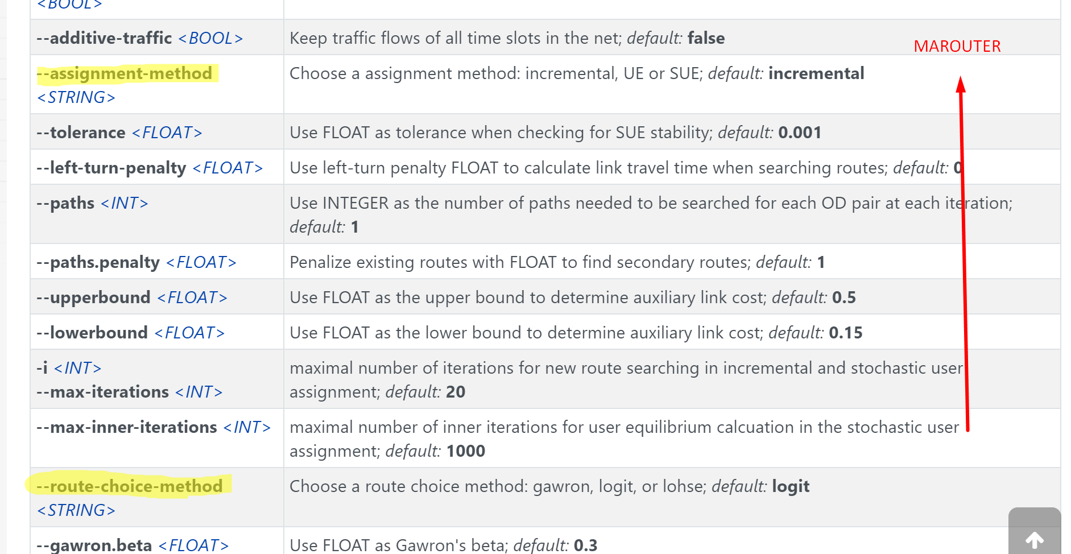

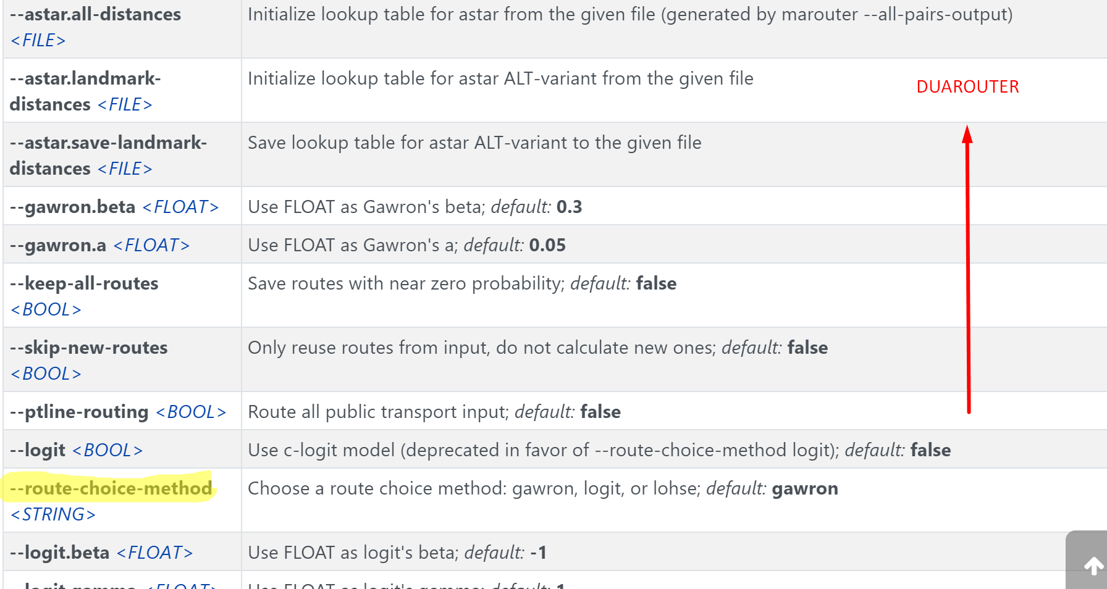









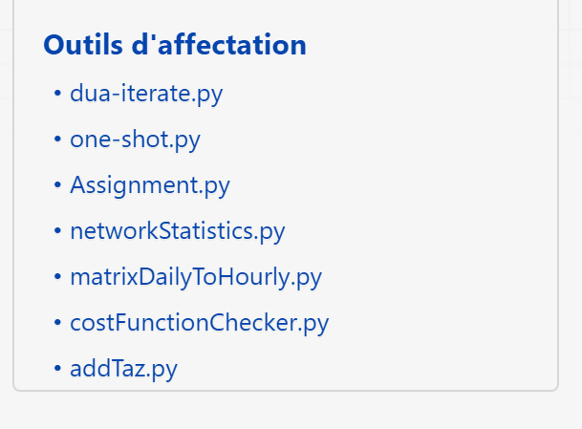

<https://sumo.dlr.de/docs/Tools/Assign.html#assignmentpy>